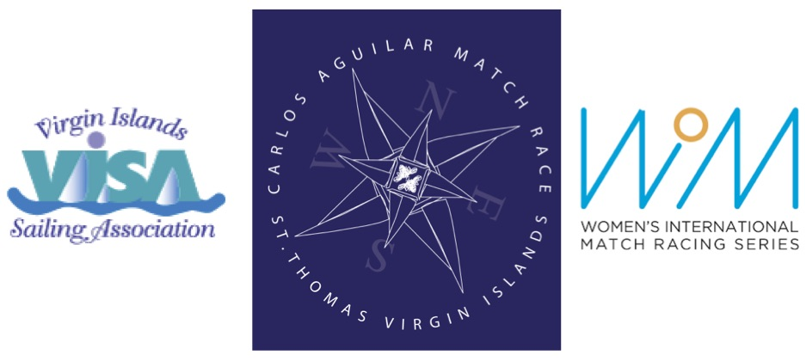
2018 CARLOS AGUILAR MATCH RACE
Virgin Islands Sailing Association
Women’s Match Race
Racing Days: 29 November - 02 December 2018
Registration and Practice Sailing: 27 – 28 November 2018

REQUEST FOR INVITATION
(Please submit by 31 July 2018)

I would like an invitation to the 2018 Carlos Aguilar Match Race:

Name:

Address:

City, State, Postcode:

Country:

Home Phone:

Work/Cell Phone:

E-mail:

World Sailing Sailor ID:

To submit request, please complete this form and e-mail to Verian Tuttle verianaguilar1@gmail.com and cc Liz Baylis liz@wimseries.com

